Contents
Contents 1
Preface 2
System introduction 3
I Installation of Patrol System 4
II USB Driver Installation Instruction 8
[Instruction] 8
[Installation steps] 10
III Quick start guide 13
1. Login 13
2. Create new route 14
3. Type-in rfid check points 14
4. Communication 15
5. Add device 17
6. Save Card 18
7. Patrol route settings 19
8. Card manage 19
9. Set Team or Group 20
10. Patrol plan settings 21
11. Crash Log 23
12. Original data 23
13. Query 24
14. Data backup and data recorvery 25
IV The function description of Patrol System 26
1. Communication 26
2. System 26
3. Source manage 30
4. Patrol data 35
Common problems and solutions 38
1. How to register rfid tags and name them 38
2. How to save data 38
3. How to delete data in patrol reader 38
4. How to update patrol reader’s time 38
5. Why all result show Miss in Query 38
6. I can see data in original data, but can’t see data in query 38
7. Records in original data not matching data in query 39
8. How to export or print out the result report 39
9. How to export or print out the original data 39
10. Why can’t open backup file 39
11. How to change driver communication port 39

Preface
Thank you for using “Patrol System”
Declare
(1) Without the company's permission, any part of this manual and the software must not be copied or plagiarism in anyway.
(2) Losses caused by improper use, the company shall not undertake any responsibility. Please must read the manual carefully to ensure your correctly set up and use this system properly.
(3) Due to technological development, the company reserves the change in this manual without notice, the right software and hardware product performance indicators.
(4) Please take care when using the product, this is the best way to extend its life.
(5) As product features constantly updated, you may be inconsistent with the actual operation of the user manual. Please contact your local dealer or contact the manufacturer directly for latest manual.
(6) This User Manual updated for November 19, 2014.

System introduction
System operation process
A. Place the rfid check points at the route site;
B. Determine the inspection route as your actual working requirement, and set accordingly in software;
C. Determine rfid check points for each inspection route, inspection time;
D. Determine inspectors.
Working process
Inspector walk around according determined time , route site , and scan the installed rfid check points with patrol reader .The patrol reader will detect and record current route site (card ID number), date and time automatically.

Once finished inspection , hand the patrol device to supervisor ,and connect patrol device to computer with USB cable . User can query and print different report , at the same time, data in device can be also deleted in software( data back up in software first is suggested)

Guard Patrol System Topological Graph
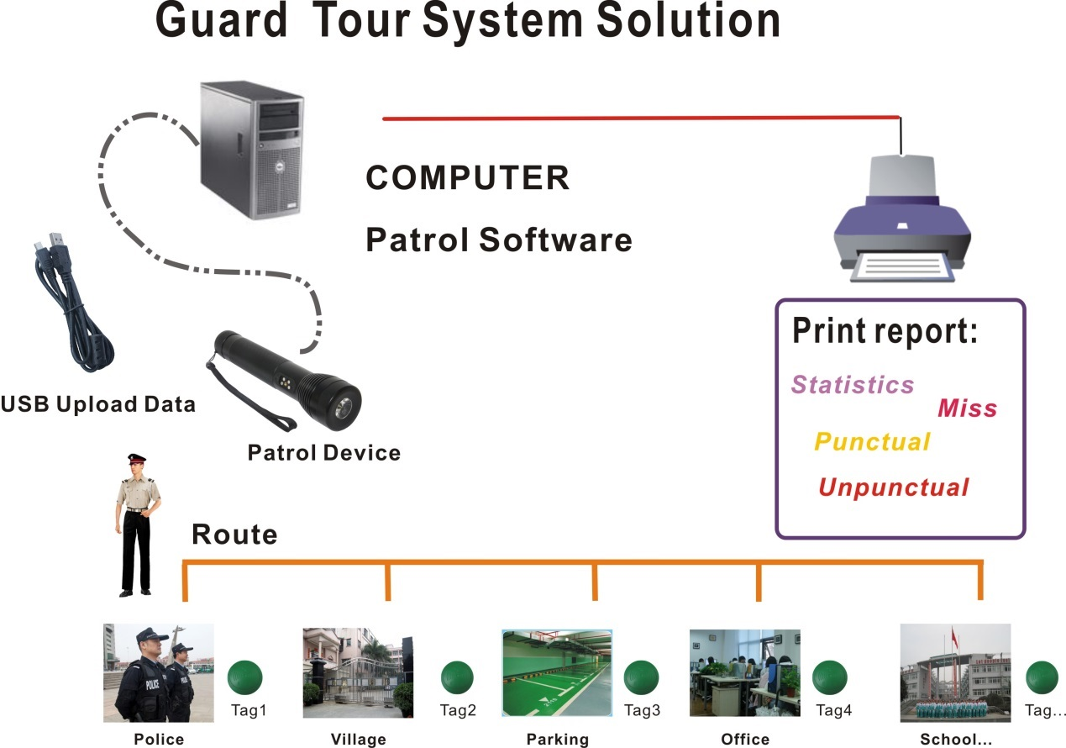

I Installation of Patrol System
[Pre-installation instruction]
This installation is based on Windows 7 operation system ,meanwhile XP and other operation system is the similar with this.
- Insert CD-ROM, open the folder and find this as below picture setup.exe
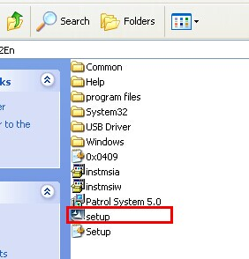
- Double click “setup.exe ”
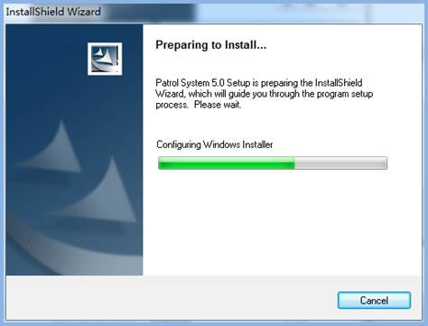
- Click “Next”
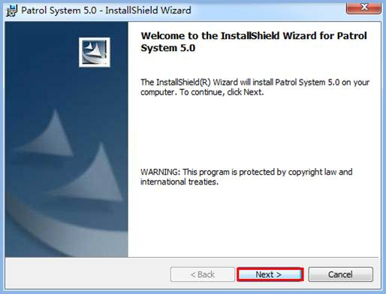
- Choose “I accept…”, and click “next”.
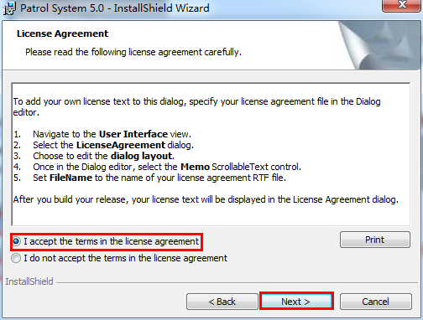
- Choose default options, click “ next” .
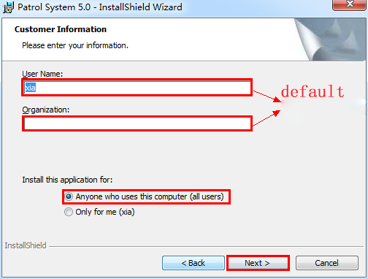
- Click “Custom”, you can choose the corresponding installation path; if choose ”Complete”, the default is installed in disk C, click” Next” finally .
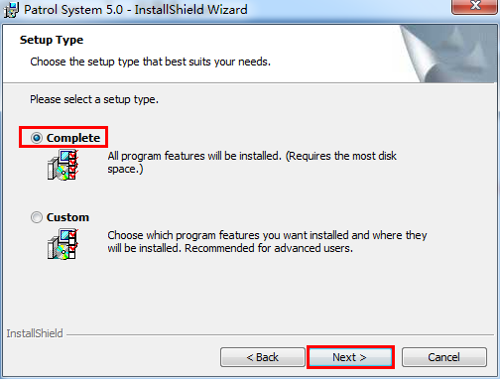

- Click “install”.
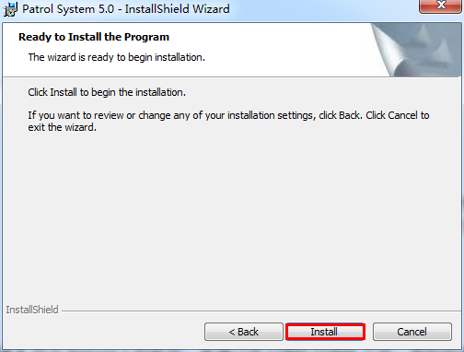
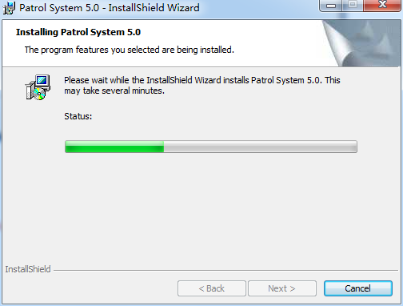
- Click “ Finish”, the software installation is complete, and there will be a desktop icon 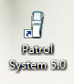.
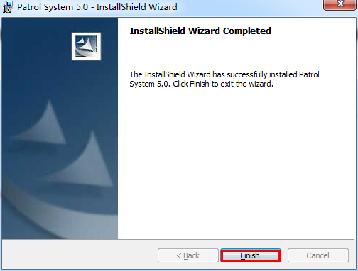

II USB Driver Installation Instruction

[Instruction]
Notice: User no need to install USB driver if your device is “Free USB driver installation” version . Please contact your supplier to confirm your device version or type.

[Instructions before installation]
How to select correct USB driver:

Different device choose USB different driver
(1) 2303 USB Driver: Patrol Stick, Color LCD Reader ( for Data cable communication type).
(2) CP210x_Driver: Mini LCD Reader, Auto-induction Reader, LED Reader, Updated LED Reader, Storage Data Communication Station, Data Communication Station, Mass Storage Color LCD Reader, Auto-induction Mini LCD Reader.
(3) If the assorted data cable is 9 pin cable for Patrol stick, Color LCD Reader, then there is no need to install driver .

Different operation system select different USB driver
(1) 2303 USB Driver:
For Windows 7 operation system ,find the folder under the disk, and install it
according the different driver
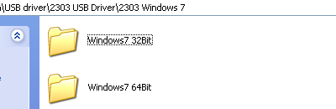
For XP or other operation system, find the folder under the disk, and install it according the different driver
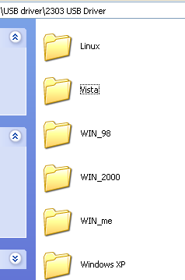
(2) CP210x_Driver：This driver has nothing to do with the type operation system , just select the driver according to the operating system of the digit
(x64 is for 64 bit operation system , x86 is for 32 bit operation system) Specific path as shown in the figure below: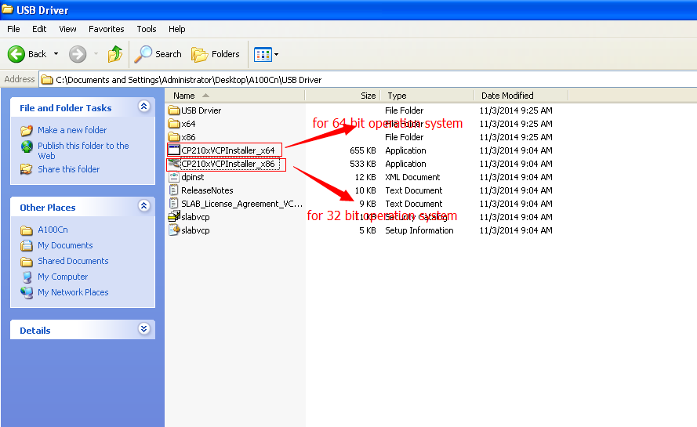
After you ensure the installation program according your patrol reader type and computer’s operation system & type , now start to install USB driver (This instruction document is said Updated LED Reader as an example ,and Patrol Software installed at Windows 7, 32 bit operation system)

[Installation steps]
1. Connect patrol reader to computer with USB cable ,right click
My computer>Manage>Device Manager to see other devices , there will be a yellow exclamation mark 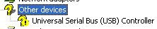, it means USB driver is not been installed .As below picture :
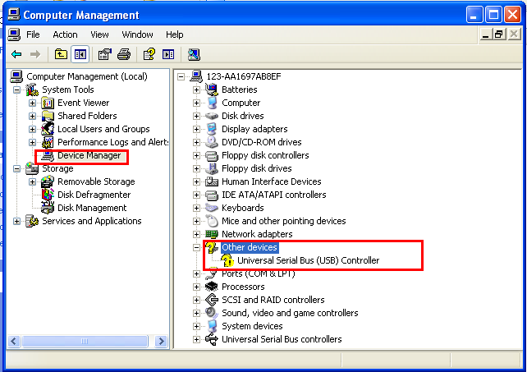

2. Find the folder USB Driver from software CD-ROM, open and double click to run CP210xVCPInstaller_x86.exe/CP210xVCPInstaller_x64.exe

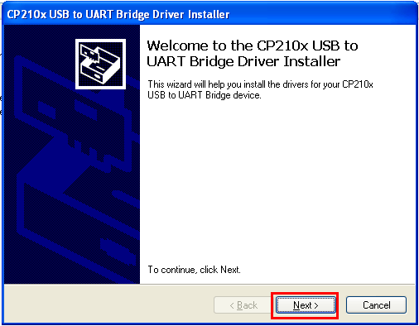

3.Click “Next”
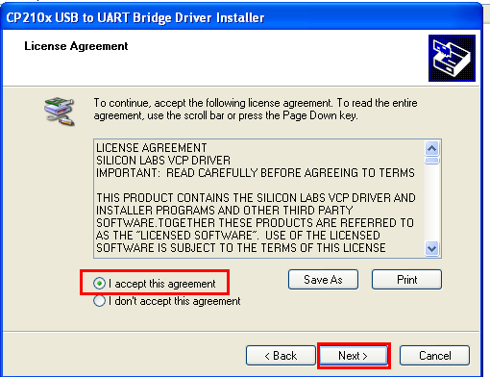

4. Click “Next”

5. USB driver installation complete , click “Finish”
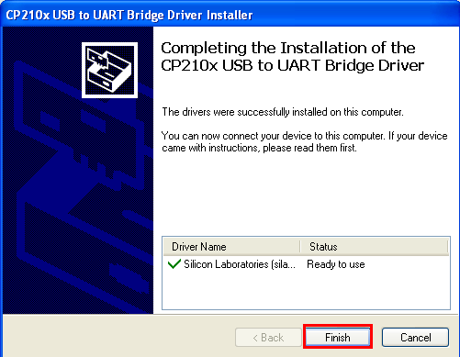
6. Once installation is complete, right click My Computer>Manage>Device Manager, choose port, you will see the driver name is Silicon Labs CP210x USB to UART Bridge(COM2)，communication port is COM2 . This means USB driver installed successfully ,and you can choose communication port COM2 to start software communication.
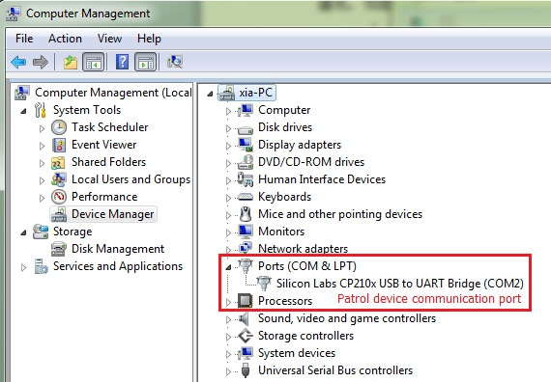

III Quick start guide
- Login
Double click Patrol system 5.0.exe in your desktop, there will be login interface as below,(Original User name：admin, no password)
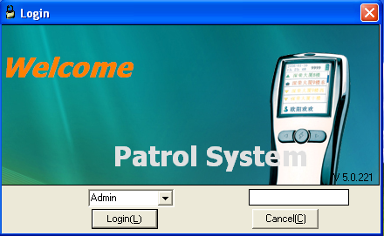
Click “Login”，you can see software as below picture:
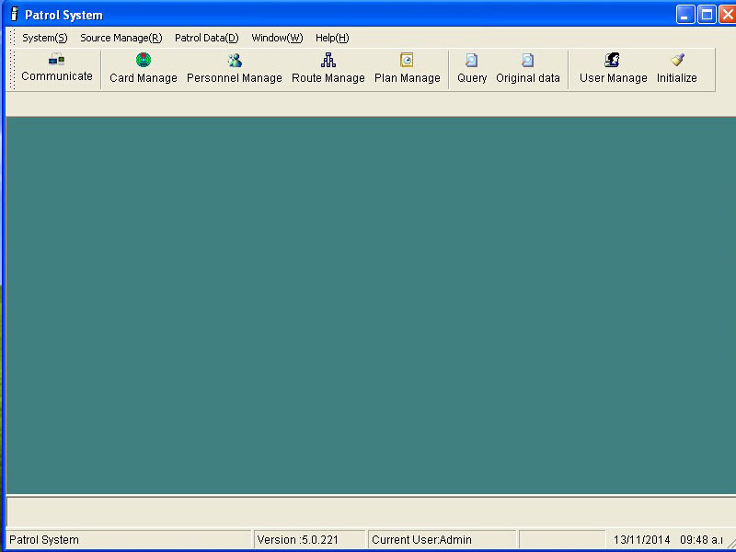
- Create new route
Create a new route to bind patrol reader
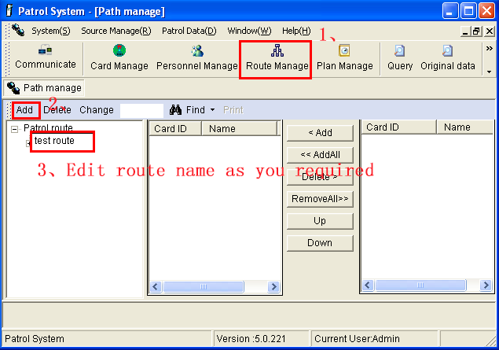
- Type-in rfid check points
Scan all rfid check points with patrol reader with the actual installation order (please must not mix the order ,you’d best to put a mark for each one )
- Communication
[Note]
Not show all different device communication interface here, but the operation steps
are the same.
(1) Patrol Stick
Connect patrol reader to computer by USB cable, select corresponding communication port, press power key, the indicator will turn to red (Only when the indicator light turn to red, the patrol reader will be in communication mode), click “Read Info” immediately, then click “Read Data”.

Software can detect and show the corresponding communication port automatically, if it show multiple port, you can check the port from device manager (Right click “My computer” -> “Device manager”), to view the related port for the driver and select it in software.
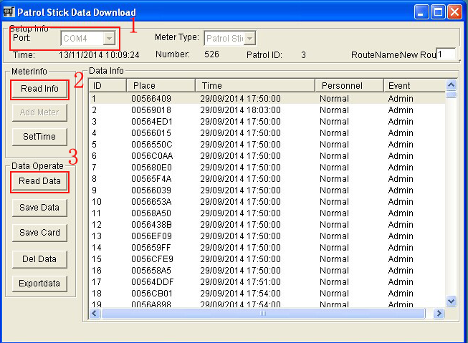
(2) Color LCD Reader
Connect patrol reader to computer by USB cable, select communication port,click “Read into” -> “Get Data”(Please must starting up device whe communication ).

Software can detect and show the corresponding communication port automatically, if it show multiple port, you can check the port from device manager (Right click “My computer” -> “Device manager”), to view the related port for the driver and select it in software.
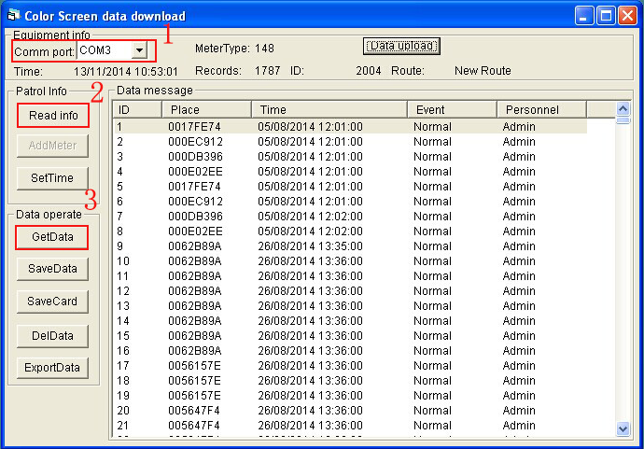
(3) Impact Recording Guard Tour System
Connect patrol device to computer with USB cable , select port, Get data.
Software can identify the corresponding port automatically and show it. If it show multiple port, you can check the port to go to device manager (right click my computer ->device manager) and select the corresponding one in software. 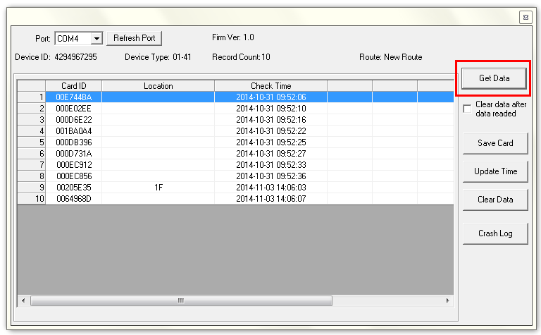
If your device is “Free USB driver” type, refresh port, the reader can communicate with software while port turn to “VD1 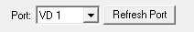”
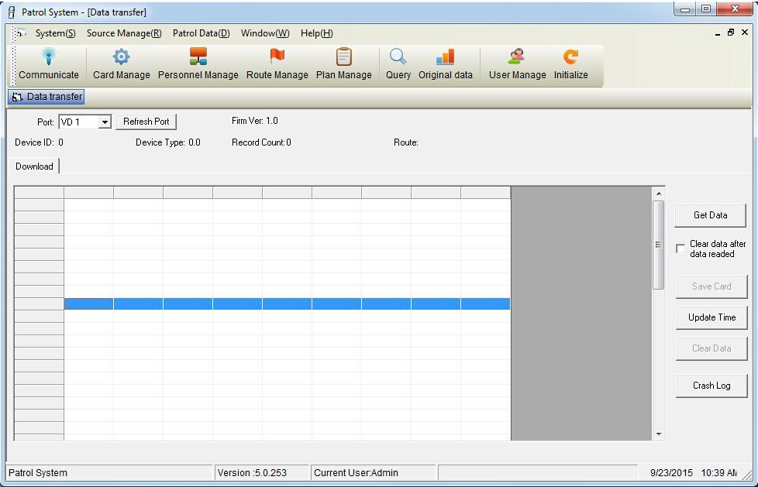
[Notice]
(1) Once click Get data, data will be saved to database automatically.
(2) Once click “Update time”, software will update patrol reader time automatically.

[Note] Following operation is take “Impact Recording Guard Tour System” as the example , other model are similar with this .

5. Add device
To realize the binding between patrol reader and inspection route . While device
communicate with software at the first time , click “Get data”, it will prompt “Add
meter”

Each patrol reader can be only bind to one patrol route, but multiple patrol reader can
be bind to the same patrol route.

Reader A- for Route A/B/C/D…N ( one to one)
Reader B- for Route A/B/C/D…N (one to one)
Route A- Reader A+ Reader B +Reader C+…..+Reader N

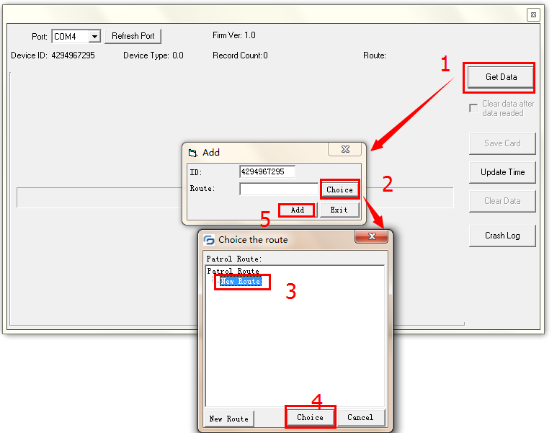

6. Save Card
After Get data from patrol reader , if check location shows with card ID number, you
should to click Save card, and classify or name each of them (double click card ID
number,you can edit them)

As below picture shows , edit all rfid tags with corresponding name then to click
“ save” .
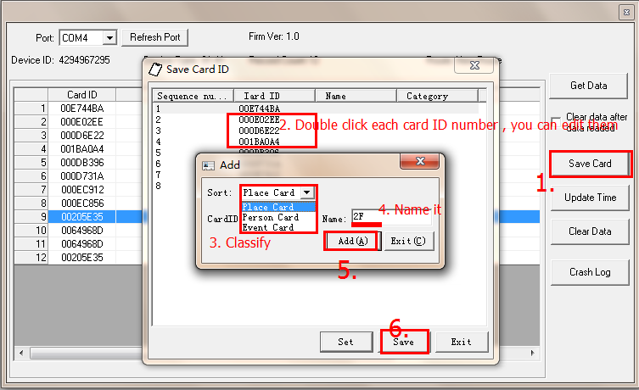

7. Patrol route settings
Add check points to corresponding patrol route
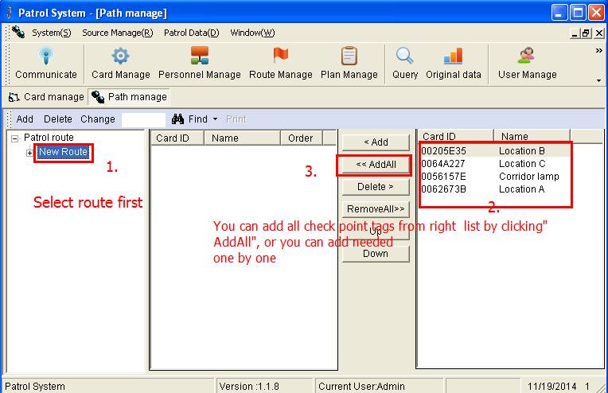

8. Card manage
(1) If you have purchased person card (employee card), you can also add person card(employee card). [Generally , person card are used for distinguish inspectors identity]
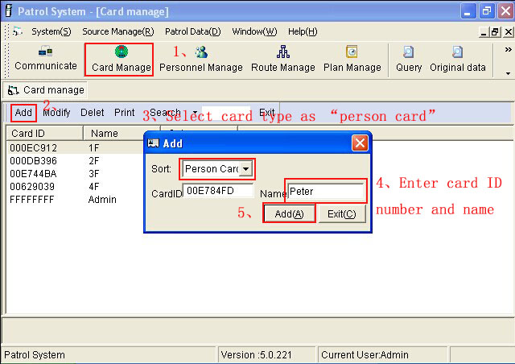
(2) If card ID number or name entered wrongly, you can also modify them under Card Manage.

9. Set Team or Group
If you have purchased person card (employee card), then you can allocate these person to corresponding team or group . If you haven’t person card, you can ignore this part . (Generally , if you want to classify whose duty at special period , you can set team or group to manage inspector . Such as Guard A should go patrol at 8:00 am- 12:00 every day , Guard B should go patrol at 12:00-16:00 pm every day , Guard C should go patrol at 16:00 pm -20:00pm every day ). As below picture :
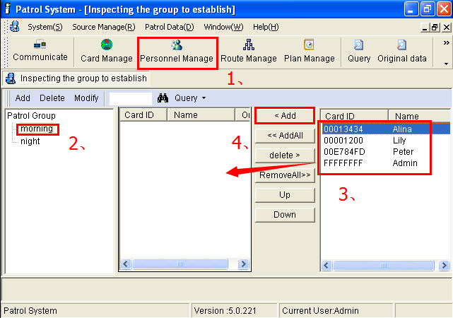

10. Patrol plan settings
Set patrol schedule for patrol route
(1) Choose the target route ,click “New plan”.
(2) All should be set: Execution Day, Late Error, Inspector( If not add this , it will regard the person card as default ,means who scan his person card during patrolling ,it will show whose attendance) ,plan type(Daily, Weekly, Monthly, Per_day),Time list .[If not tick “ auto-generate “, there will be only one piece plan . Auto-generate allow you to set batched plan which with same time interval ]
(3) Save plan
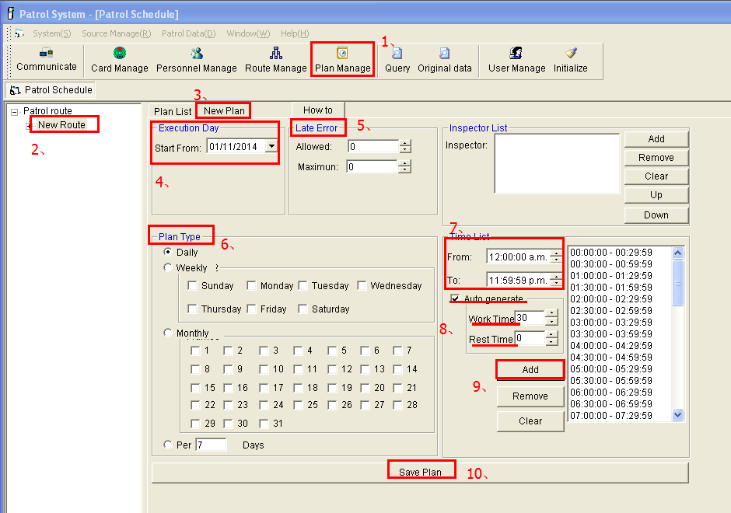

Once save plan, you can check existed plan under “Plan list”, if you want to modify
existing plan , you should delete the existing plan first .
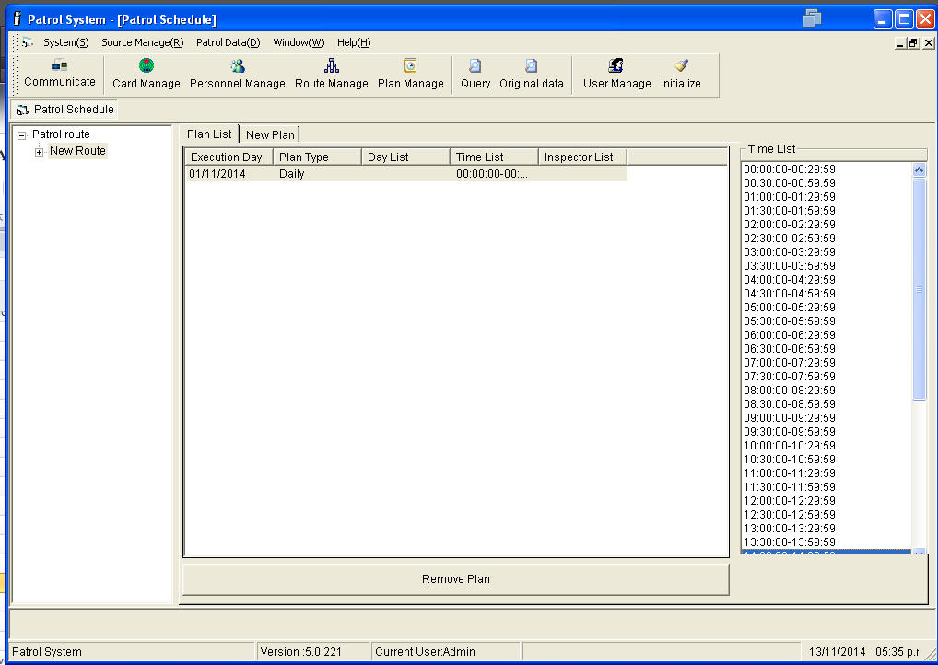
[Notice]
So far, the basic setting of software (Patrol route, inspector ,Patrol plan) are finished. Then guard can take the patrol reader to do patrol activities as required .

11. Crash Log

[Only for model “Impact recording Guard Tour System”]
These Patrol reader with the function to record crash logs . You can check and view the
records under communication interface. Click “Communication”->Get Data->Crash Log .
And the records can be exported and printed out.
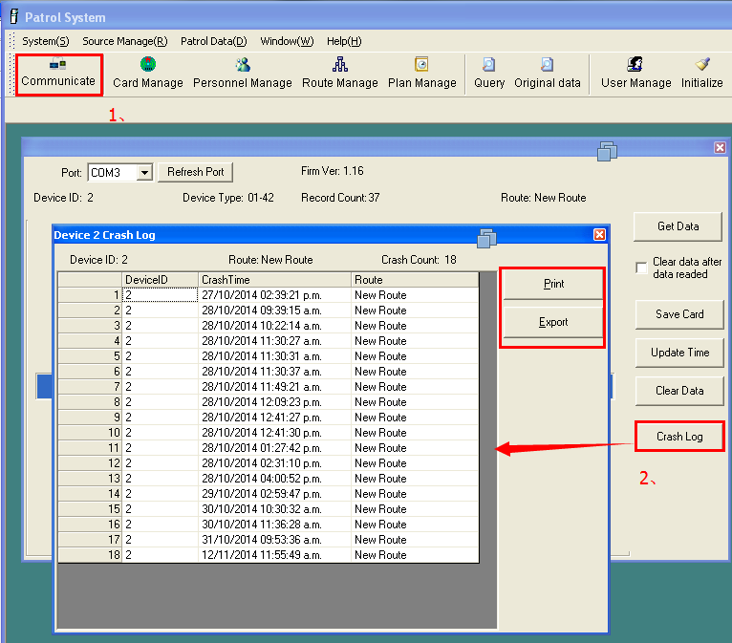

12. Original data
(1) After checking around, get data from patrol reader and save automatically .
[Notice]If inspector with person card ,please scan their person card first before starting patrolling
(2) View original data
Once data saved, you can view related records under original data
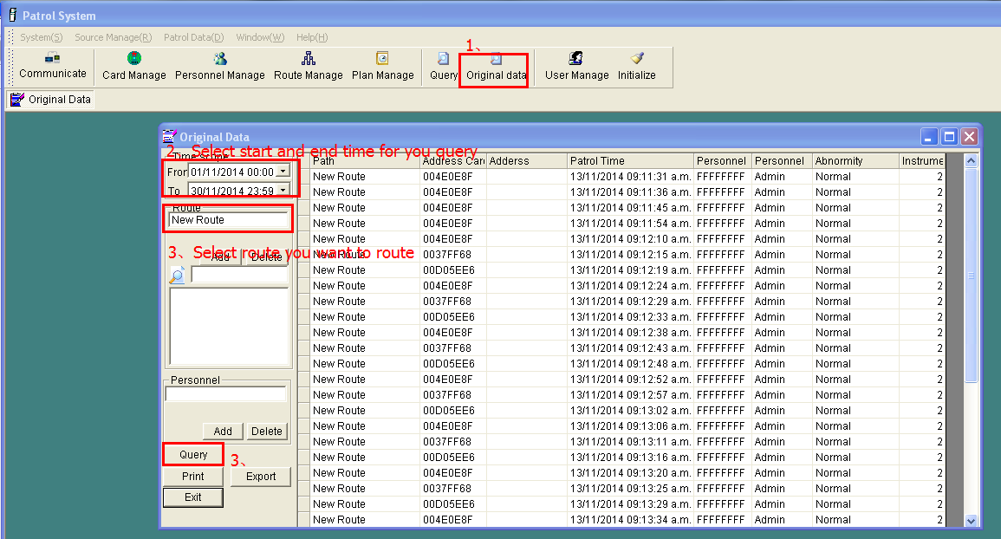

13. Query
Query is main for estimating whether the patrol result Punctual or Miss by matching with scheduled plan .
- Choose your target query time and route ,click “Query”
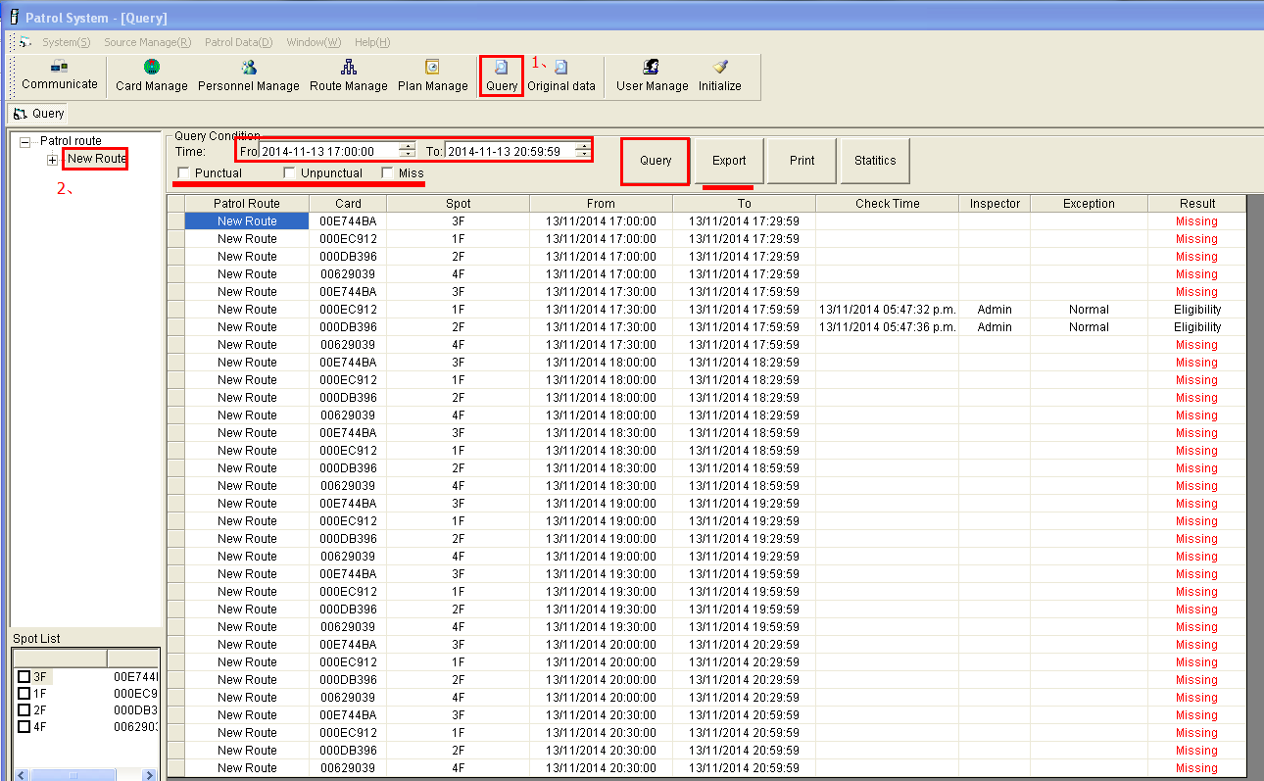
- Print out and export report
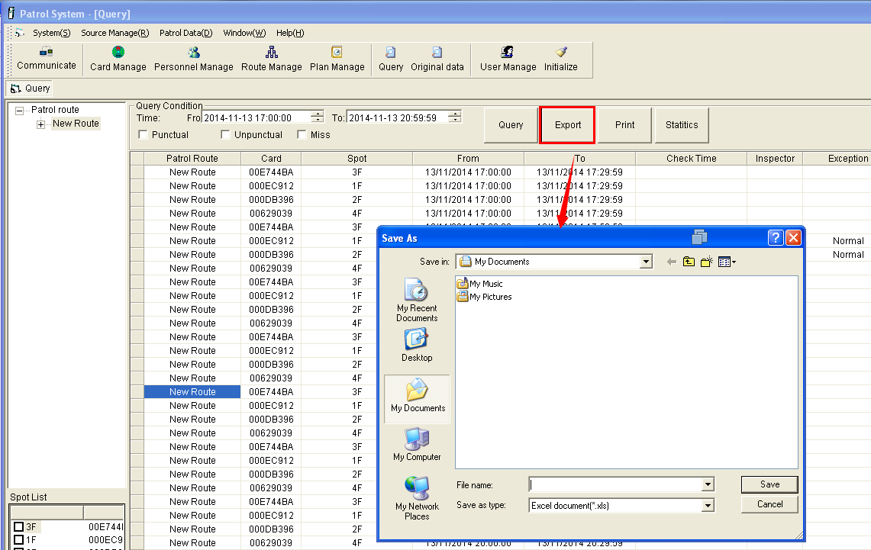
(3) Statistics
Data statistics is main for querying the qualified rate at the specified period.
Two statistical types : By route and by inspector
Click “ Statistics “-> Count for route, you will see as below picture :
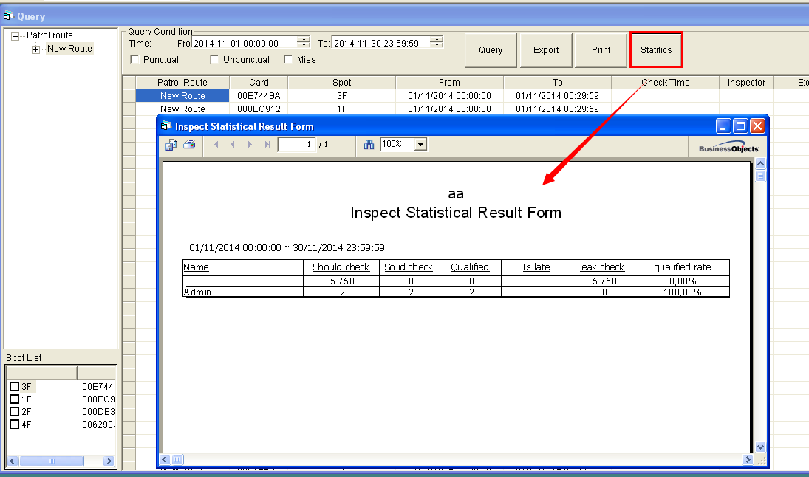

14. Data backup and data recovery
System—Data backup
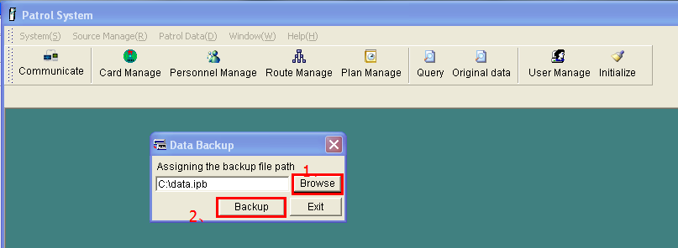
System—Data recovery
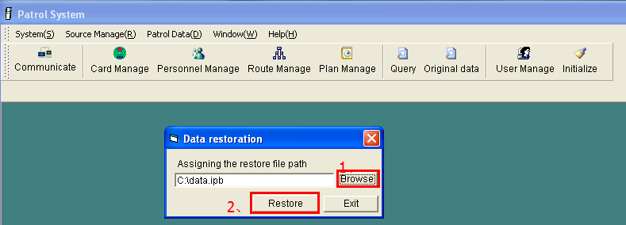
[Notice]To avoid accident loss of data, data backup habit is suggested.

IV The function description of Patrol System
- Communication
Get data, Save card, Update time, Clear data, Crash Log
Get data:(1) Download all data info from patrol reader to software
(2) After data downloading ,software will store all data info in patrol reader to database automatically
(3) After data downloading, software will update patrol reader time automatically
Update time：Synchronize the time of patrol reader and computer
Save card：Set card type and name (eg: place card ,person card, event card),which can
avoid error when manual input.
Clear data :Clear all data in current patrol reader , can’t be recovered again
Crash log: Read out crash logs count and crash time , and can print out or export
these records

System
System setup, data backup, auto backup setting, data recovery, customer settings, re-login, exist

2.1 System setup
Change Patrol System software background picture and background color, custom
company name and tick whether show choose device type form. As below picture :
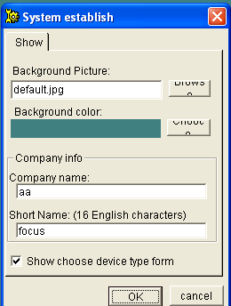

2.2 Data backup
Backup all data in software for standby use ,including “ Patrol plan , Card
manage ,Inspector ,Original data and etc “.As below picture
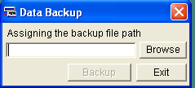

2.3 Auto-backup settings
After ticking auto-backup, set the data storage path and backup period(you can choose every day, per 3 days ,every week, every month),it will backup automatically at stipulated time to prevent data lost .As below picture
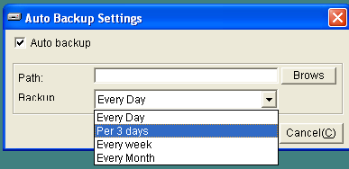

2.4 Data recovery
You can recover the data by backup files ,which can reduce much work to reset basic software information .As below picture:
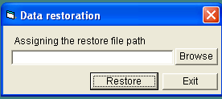

2.5 Customer settings
You can login with account Admin to change the Admin’s password and add other sub users ,also you can set sub user accounts permission settings .Admin is the supreme authority account, can’t be deleted ,but password can be changed. As below :
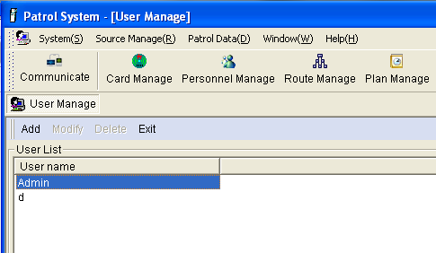
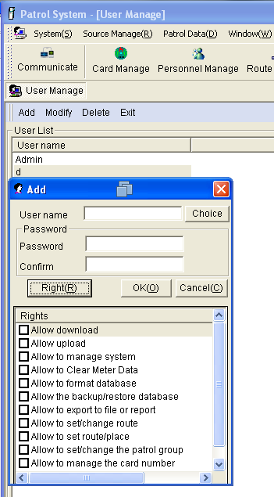

2.6 Re-login
Exist current user and re-login with a new user account . As below picture :
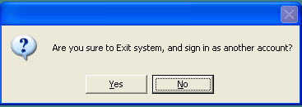

2.7 Exist
Exist this system . As below picture :
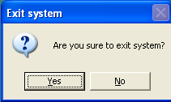

Source manage
Card Manage, Personnel Manage, Route Manage, Events Manage, Equipment
Manage, Plan Manage, Crash Logs
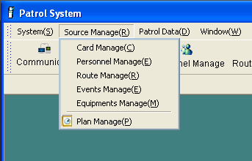

3.1 Card Manage
Add, Modify, Delete different card (eg: place card, person card, event card ).As below picture
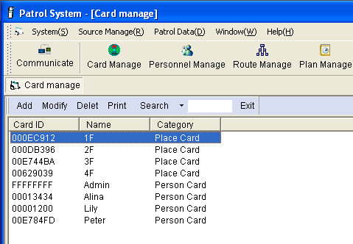

3.2 Personnel Manage
Add, Modify, Delete team or group, Add inspector to related team or remove
inspector from team. This is process to assign inspector to related team. As below picture:
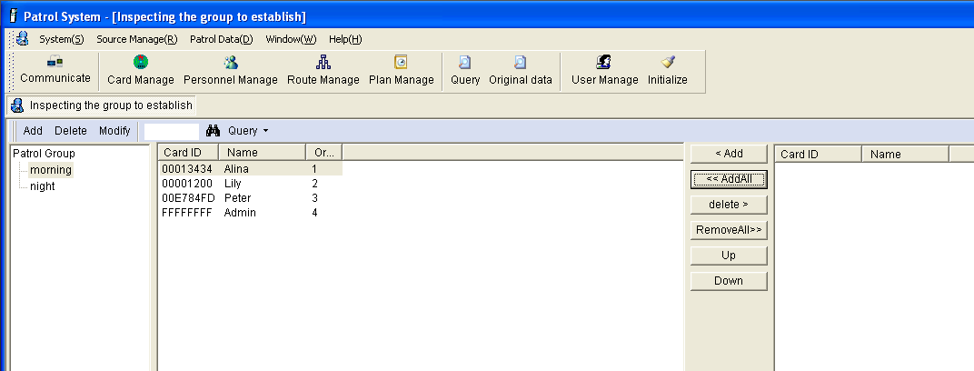

3.3 Route manage
Add, modify , delete route, add check points to related patrol route or remove check
points from patrol route .This is process to assign check points to related patrol route.

As below picture :
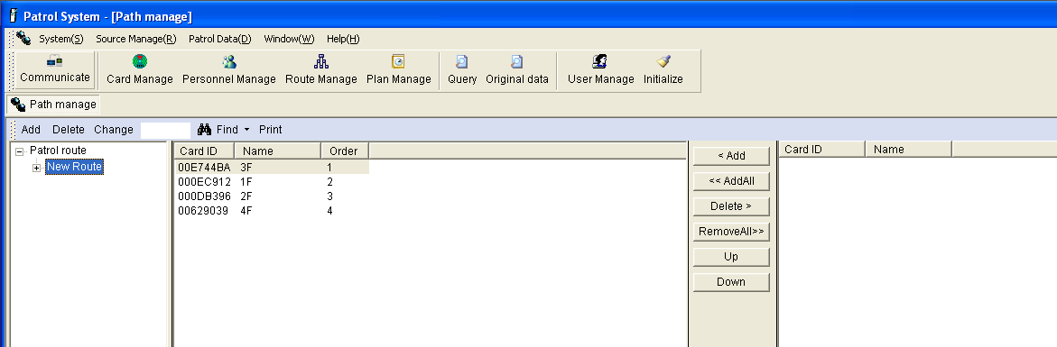

3.4 Events manage
Set event name. As below picture:
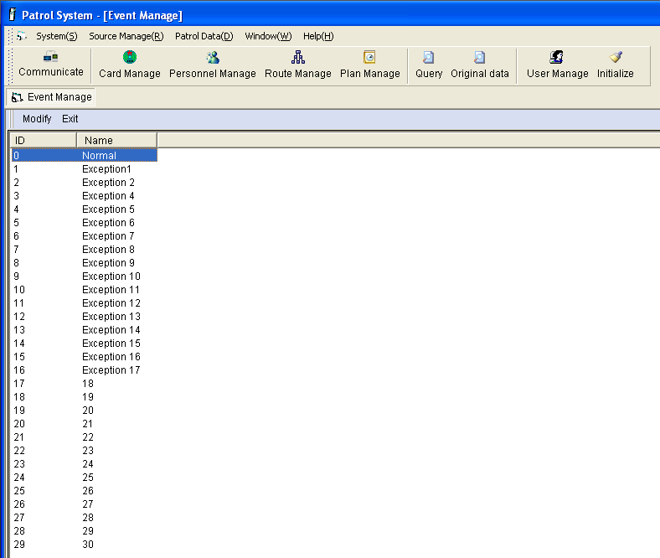

3.5 Equipment manage
Add new patrol reader to related patrol route ,modify bind route of patrol reader, delete patrol reader .
One unit patrol reader can be only bind to one route ,but one patrol route
can bind many patrol reader (means many patrol reader can be under the
same patrol route )
As picture :
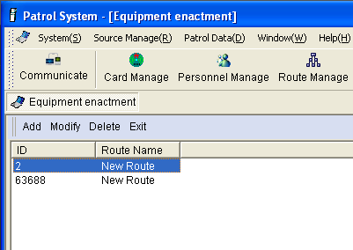

3.6 Plan manage
You can set inspectors working time, inspectors , plan type under Plan manage
Plan function : Execution day, Late error, Inspector ,Plan type, Time list
The default execution day is the 1st of each month , can be changed
You should select a patrol route first, at the same time , only one patrol plan can be set at the same execution time .
[Inspector]
Add inspector: Add inspector (well allocated to patrol team) to patrol plan, so that you can know who is do patrol activity
If not add inspector, it will regard person card as default .
[Late error]
Allowable：Means out of the given patrol time , the allowable late time .If inspector do patrol within this period , result will be estimated as qualified.

Maximum：Means out of the given patrol time , a maximum time limit .If inspector do patrol within this period ,result will be estimated as late .Out of this period ,result will be omit(miss).
For example：
Patrol period is 8:00~12:00(240 minutes) ，rest time is 20 minutes(rest time must be
larger than maximum error) ,set allowable error as 5 minutes , maximum error is 10
minutes. Then data within the period 7:55~12:05 will be qualified, and data within
period 7:50~7:55 and 12:05~12:10 will be late, data within other period will be
omit(miss) .As below picture :
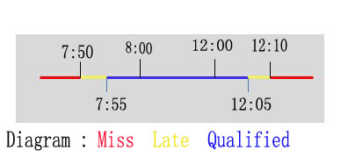

[Auto generate]
To subdivide the inspectors patrolling time during the appointed start and end time.

Work time : Means inspector must finish all check points which under current patrol
route at this appointed period . If not finished , system will judge it as omit .

Rest time：Means how long can inspector take a rest after they finish all check points
which under current patrol route

[Plan Type]
There are 4 types in total , once plan generated with one of these types, no need to
re-set again, system will generate plan regularly with this type automatically .
Every day：Perform from 1st each month , and there will be same plan everyday
Weekly：The system defaults the inspection program start from Monday to Friday every week (you could go to software system to modify workdays)
Monthly：You can specify one day in a month or more days to execute the plan
Per_ days：Can specify how many days should inspectors to preform each patrol plan , and any day within this period will be qualified .As below picture :
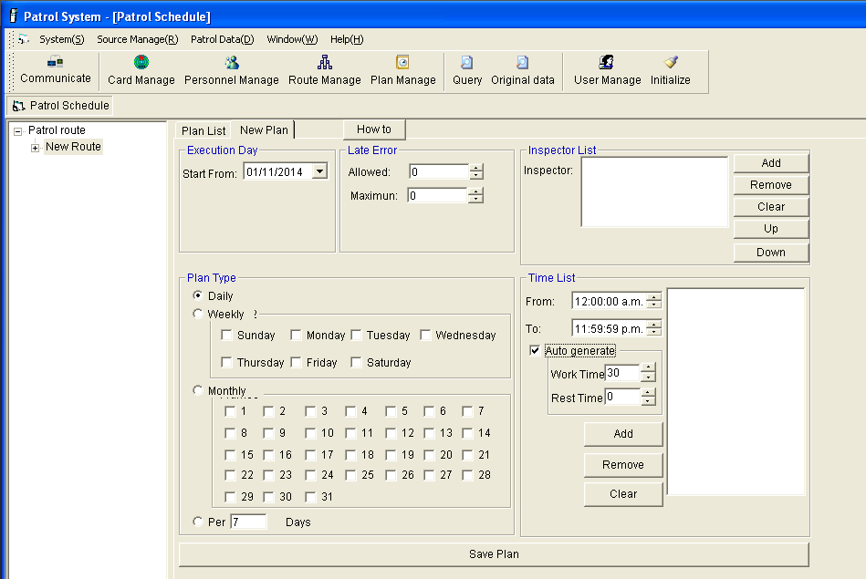

Patrol data
Data query ,Original data, Initialize Data

4.1 Data query
Summary of inspectors inspection situation , no need data analyze , according set patrol plan for current patrol plan, can query result “Punctual”, “Unpunctual”, “Miss” accurately, and can generate related report automatically , you can export report with format htlm, txt.
As below picture :
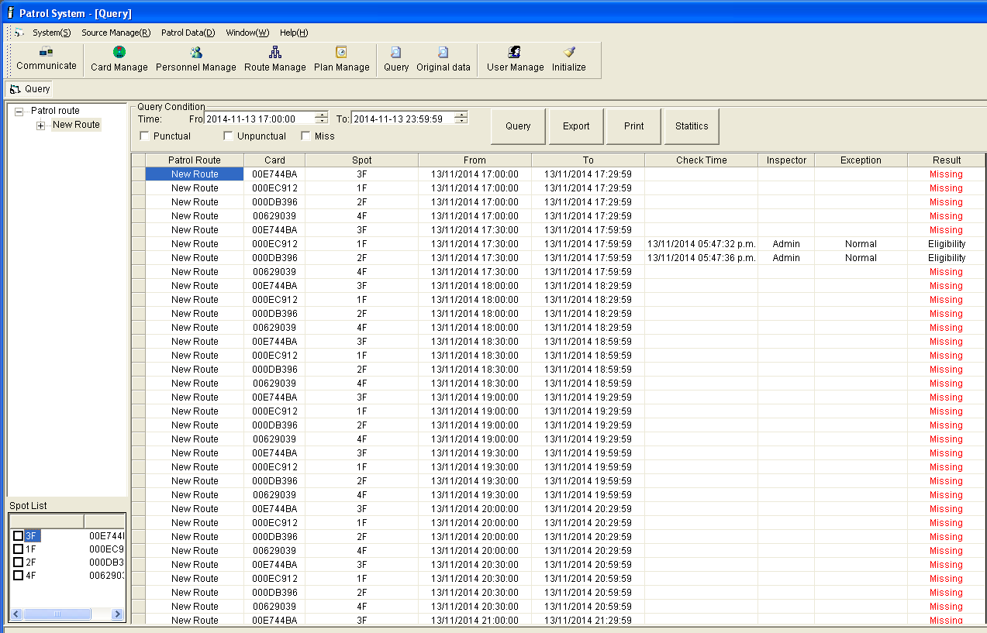

[Statistics]
Count the Should check, Solid check, Qualified, Is late, Leak check within
specified period , and calculate the qualified rate .
2 statistics method :Count for route , count for inspector.
Count for route, as below picture :
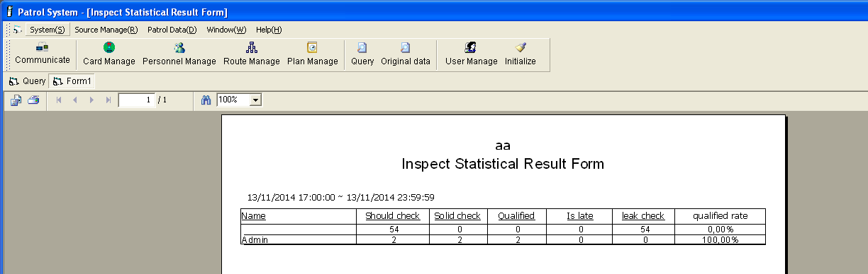

4.2 Original data
Query the original data of patrol reader, including all any patrolling data, check points
card ID(Address card) ,check point name (Address), patrol time, personnel card,
personnel, abnormality, instrument(Patrol reader ID).Can can print out or export
report(*.xls)
Query method: By route and by personnel
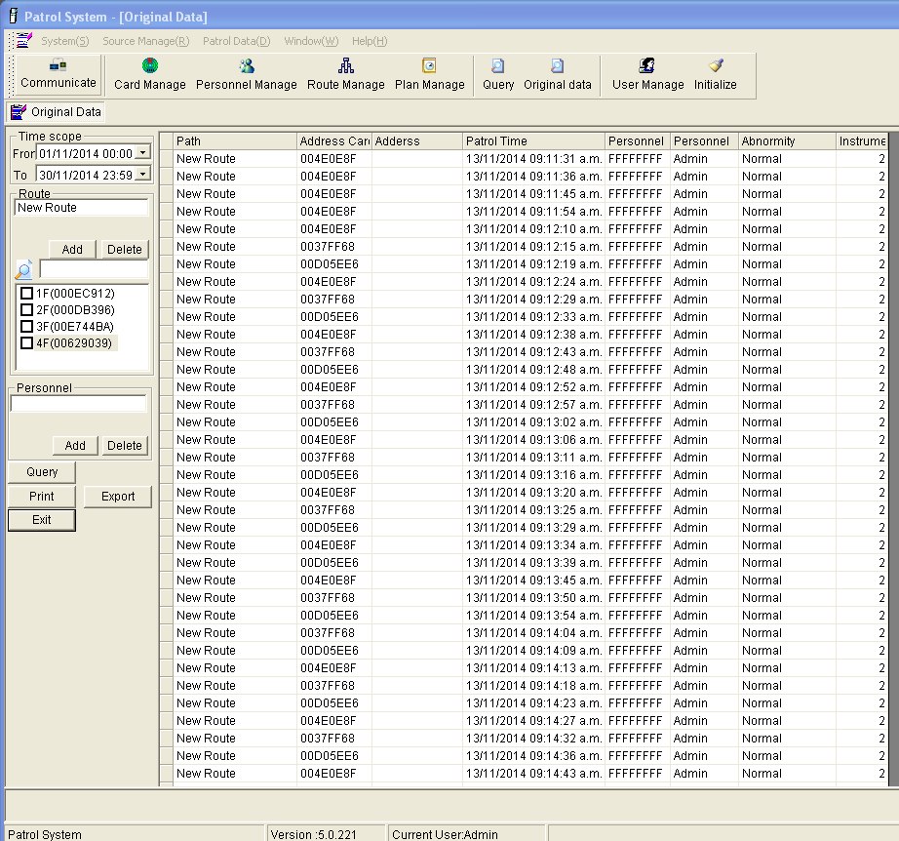

4.3 Initialize data
Clear all or part data in “ Patrol system “,data can’t be recovered, suggest you to clear
selectively, use with caution please. As below picture :
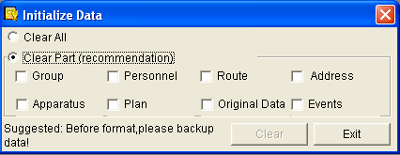

4.4 Crash Logs
Query the crash time and crash count in software for all patrol reader that bind to patrol route already , and you can also export and print out the report . 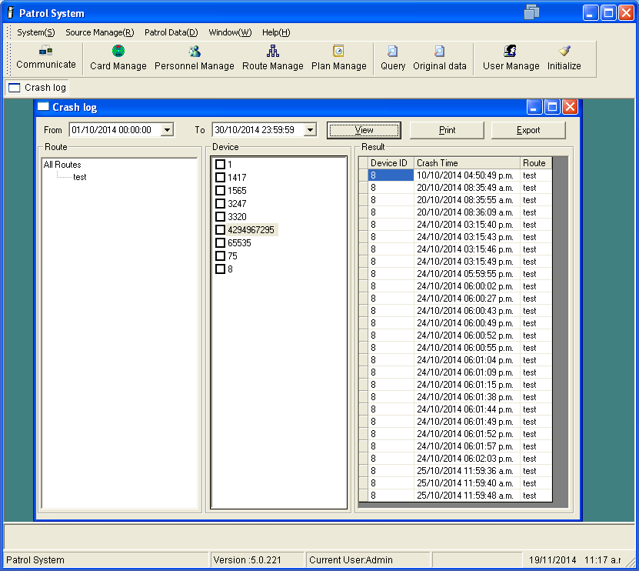

Common problems and solutions
- How to register rfid tags and name them
Scan all rfid tags by patrol reader in order , and connect patrol reader to computer with USB cable, read data out while communication , then you can save card for edit.
- How to save data
Connect patrol reader to computer for communication, click “ Get data”. Software will save data automatically once click “ Get data” .
- How to delete data in patrol reader
[Notice]This function is to delete all data from patrol reader , can’t delete data selectively. So you’d best to save and backup data first before deletion.
Connect patrol reader to computer for communication , click “ Get data “ ->“ Clear data”.
- How to update patrol reader’s time
Connect patrol reader to computer for communication, select related communication port . Click “Update time “.

5. Why all result show Miss in Query
Scheduled patrol time is not the same as actual attendance time, you can query data to contrast with original data.

6. I can see data in original data, but can’t see data in query
Scheduled patrol time is not the same as actual attendance time .

7. Records in original data not matching data in query
For example , in original data you can see data at August 8, 2014 on four o'clock and seven o’clock in the morning , but in query , you can only see data at August 8, 2014 on four o'clock in the morning.
Some problem with patrol plan settings , because you have set four o’clock to seven o’clock to the same inspection period wrongly. You should re-set the plan again according your actual situation .

8. How to export or print out the result report
During data query , select corresponding patrol route and patrol period. Click “ Query “ ,then
click “Print “ or “ Export “ .

9. How to export or print out the original data
In the original data, select corresponding patrol route and patrol period, Click “ Query “ ,then
click “Print “ or “ Export “ .

10. Why can’t open backup file
In software ,file(*.ipd) is just a backup file generated while backup , it can only be recovered through software, then you can see all information in software.

11. How to change driver communication port
For software Patrol 1.0, the COM port is within COM1-COM16, if the COM port is
not in this , you should to change COM port for use .

Change method: Right click Patrol reader USB driver (Silicon Labs CP210xUSB to UART Bridge (COM* > Properties>Port settings >Advanced>Select COM port between COM1-COM16 ,click”OK”.As below picture ：

